**1.INTRODUCTION :**

**•**Project Tittle : Fitflex : Your personal fitness companion

•Team Members :

|  |  |
| --- | --- |
| ROLL NO | NAME |
| Per104C24UG104CAP026 | RASHIYA J |
| Per104C24UG104CAP029 | SANTHIYA R |
| Per104C24UG104CAP030 | SOWMIYA M |
| Per104C24UG104CAP031 | SRINITHI S |
| Per104C24UG104CAP033 | SUGANTHI E |

**\*Welcome to the future of personal fitness**

A personal fitness companion, like a personal trainer or digital app, introduces itself by stating its role in helping you achieve fitness goals, outlining its personalized services such as custom workout plans and guidance on exercise form, and often includes a call to action to start your journey. A good introduction highlights the companion’s unique ability to provide support, accountability, motivation, and a tailored experience to fit your schedule and needs.

Key Elements of a Personal Fitness Companion’s Introduction:

~Your Role and Goals:

The companion explains its purpose is to guide you toward your specific fitness goals and a healthier lifestyle.

~Personalized Services:

It will mention offering customized workout plans, nutritional guidance, and education on performing exercises safely and effectively.

~Accountability and Support:

The companion introduces itself as a source of motivation and accountability to help you stick to your fitness routine and form healthy habits.

~Expertise and Credentials:

Depending on the type of companion (human or digital), it may highlight its expertise, experience, or specialized training in fitness.

~Flexibility and Customization:

An introduction might emphasize its ability to accommodate your schedule, preferences for workout locations, and personal requirements.

~A Call to Action:

A compelling introduction ends with an invitation or call to action, encouraging you to start your fitness journey with their help.

Examples of What a Companion Might Say

“I’m your personal fitness companion, ready to design a workout plan tailored to your unique needs and help you reach your health goals”.

“Let’s build a strong and healthy lifestyle together with personalized guidance and consistent support”.

“I specialize in making your fitness journey effective and enjoyable, offering customized plans that fit your busy schedule”.

“Together, we’ll ensure you perfect your form, stay motivated, and celebrate every step of your progress”.

**•Target Audience:**

Athletes: Seek specialized training to improve performance or support their sport-specific goals.

Busy Professionals & Executives: Need time-efficient, discreet, and highly personalized training programs to fit into demanding schedules.

•**Project Goals and Objectives:**

Project objectives for a personal fitness companion often focus on enhancing health-related fitness components like cardiovascular endurance, muscular strength, muscular endurance, flexibility, and body composition to achieve overall well-being, weight management, and disease prevention. A successful project aims to help users establish sustainable, healthy lifestyle habits by providing personalized guidance, tracking progress, and promoting motivation, making fitness an enjoyable and challenging part of their daily lives.

**•Key project objectives:**

**A personal fitness companion project aims to achieve the following:**

**Personalized Workout Plans: To create customized workout routines tailored to the user’s fitness level, goals, and preferences.**

**Activity Tracking:**

**To monitor and record the user’s physical activities, such as steps taken, exercises completed, and workout duration.**

**Progress Monitoring:**

**To provide tools for users to track their progress over time, such as changes in weight, body fat percentage, or performance in specific exercises.**

**Goal Setting and Motivation:**

**To assist users in setting SMART fitness goals (Specific, Measurable, Attainable, Relevant, Time-bound) and to provide motivation and encouragement to help them stay on track.**

**Improved Health & Wellness:**

**To facilitate users in achieving broader health and wellness goals, such as:**

**~Weight loss and fat reduction.**

**~Increased muscle mass and improved body composition.**

**~Better cardiovascular health and increased endurance.**

**~Improved flexibility and range of motion.**

**~Enhanced sleep quality and stress management.**

**User Experience:**

**To deliver a responsive, intuitive, and engaging user interface for ease of use.**

**Future Enhancements:**

**To incorporate features like social sharing, custom workout creation, and integration with smartwatches for a comprehensive fitness ecosystem.**

**Target Audience:**

The primary target audience for such a project would be:

Age Demographics: Millennials (age 25-40) and Gen Z (ages 18-24) represent the largest user segments for fitness apps.

Motivation Drivers: Individuals looking for support in weight loss or who want to increase their general activity levels are key demographics.

Individuals with Chronic Conditions: The companion could also be designed for people with chronic medical conditions or those who are overweight, needing careful guidance and a structured approach to activity.

[**https://play.google.com/store/apps/details?id=homeworkout.homeworkouts.noequipment**](https://play.google.com/store/apps/details?id=homeworkout.homeworkouts.noequipment)

**Project Goals and Objectives:**

**Improve Overall Health and Well-being:**

**To feel better, have more energy, and enhance mood and sleep quality through regular physical activity.**

**Increase Fitness Levels:**

**To improve cardiovascular health, strength, and endurance to a level that supports a healthy and active lifestyle.**

**Develop Sustainable Habits:**

**To create routines that are realistic and enjoyable enough to be incorporated into a person’s lifestyle long-term, rather than being temporary.**

**Key Features:**

**To accomplish these objectives, a personal fitness companion might include:**

**Wearable Device Integration:**

**Connecting with fitness trackers to collect real-time data on activity, heart rate, sleep, and more for personalized feedback.**

**AI-Driven Personalization:**

**Using artificial intelligence to analyze user data and create tailored workout plans, nutritional advice, and actionable insights.**

**Goal Setting & Progress Tracking:**

**Enabling users to set SMART (Specific, Measurable, Achievable, Relevant, Time-bound) goals and providing tools to monitor their progress towards achieving them.**

**Gamification: Incorporating elements of gaming, such as challenges, rewards, and leaderboards, to make the fitness experience more enjoyable and motivating.**

**Social Integration:**

**Features that allow users to connect with friends, share progress, and participate in group challenges to build a supportive community.**

**Educational Content:**

**Providing resources on exercise techniques, proper nutrition, and the principles of physical fitness to help users make informed decisions about their health.**

**Pre Requisite :**

**User Research:**

**Understanding the target audience’s motivations, barriers, and preferred fitness activities is crucial for designing an effective and engaging companion.**

**Fitness Principles:**

**A foundational understanding of the five components of physical fitness (cardiovascular endurance, muscular strength, muscular endurance, flexibility, and body composition) and how to balance them in a program.**

**Goal Setting Framework:**

**The ability to guide users in setting clear, specific, and achievable fitness goals, and to break them down into manageable mini-goals.**

**Technology Integration:**

**The capacity to incorporate technological features such as wearable trackers, mobile app integration, and data analytics to provide real-time feedback and support.**

**Content and Expertise:**

**Access to reliable information on exercises, nutrition, and wellness to ensure the advice provided by the companion is accurate and beneficial.**

**Project Structure:**

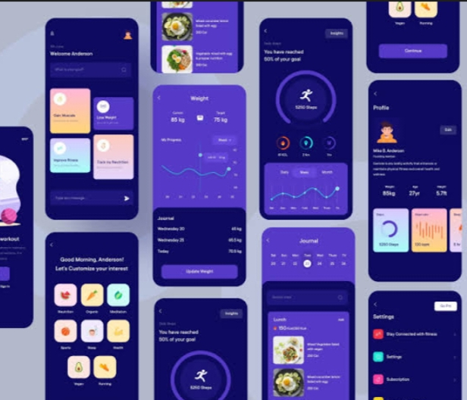**A typical structure would involve several key modules:**

**User Profile Management: Handles user data, goals, fitness levels, and preferences.**

**Exercise Database: Contains a comprehensive library of exercises with details like muscle groups, intensity, and instructions.**

**Workout Planner: A core component for creating, scheduling, and modifying personalized workout routines.**

**Activity Tracker: Integrates with device sensors (like accelerometers) to track daily steps and activities.**

**Data Logging and Analysis: Records workout sessions, nutritional intake, and other relevant data, then processes it for progress reports.**

**User Interface (UI/UX): Designs the app’s interface for seamless user interaction and a positive user experience.**

**Coding Considerations**

**Programming Languages:**

**Swift/Objective-C: For native iOS applications.**

**Kotlin/Java: For native Android applications.**

**JavaScript (with React Native/Flutter): For cross-platform development to reach both iOS and Android users from a single codebase.**

**Project Flow:**

**The project typically follows a cyclical or repeating process:**

**Assessment:**

**Gather information about the user’s current fitness level, goals, and any limitations.**

**Understand their preferred activities and any existing equipment or resources.**

**Design (Goal Setting & Planning):**

**Set specific, measurable, achievable, realistic, and timely (SMART) goals with the user.**

**Create a comprehensive fitness plan that includes aerobic fitness, strength training, core exercises, balance, and flexibility.**

**Implementation (Getting Started):**

**Provide clear instructions and guidance to start the exercise program.**

**Assemble or identify the necessary equipment or environments for workouts.**

**https://play.google.com/store/apps/details?id=com.google.android.apps.fitness**

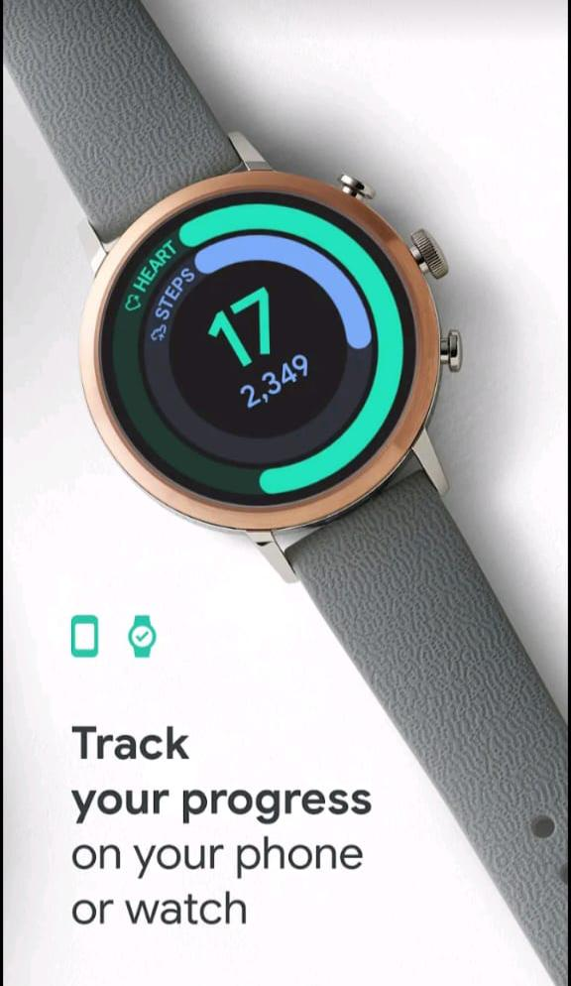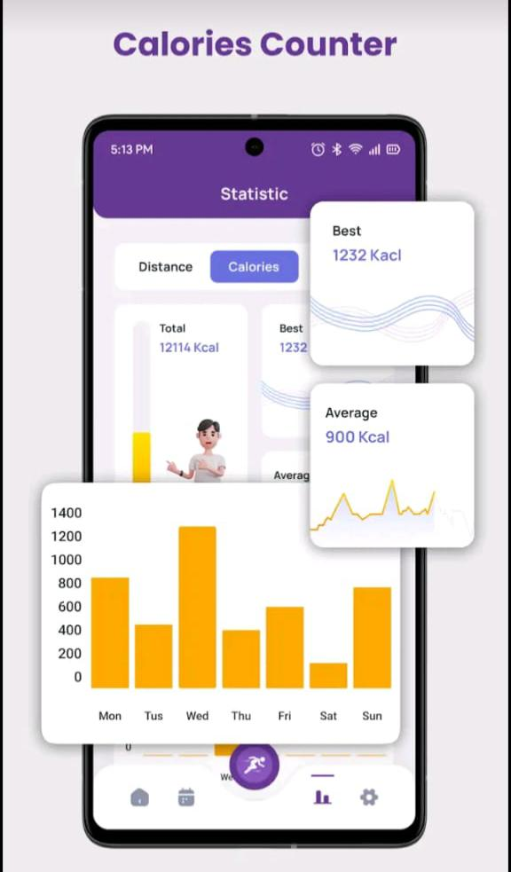

**Coding :**

**To get started with “code for fitness app,” you need to first define your app’s niche and core features, then choose your development approach, which can range from using no-code builders like Buildfire for simpler apps to custom coding for complex, feature-rich applications. For a custom-coded app, you’ll need to consider technical architecture, front-end and back-end development, and potentially AI integration, along with the specific programming languages and platforms for iOS and Android.**

**Define Your App’s Scope and Features**

**Niche:**

**What specific problem will your app solve? (e.g., home workouts, nutrition tracking, gym routine planning, AI-powered coaching).**

**Core Features:**

**Brainstorm the essential functions, such as workout libraries, progress tracking, meal plans, or social features.**

**Monetization:**

**Decide how your app will generate revenue (e.g., subscriptions, premium features, advertising).**

**Choose Your Development Path**

**No-Code/Low-Code Platforms:**

**For faster, simpler apps, consider platforms like Buildfire, which provide templates and a drag-and-drop interface to create a basic fitness app without needing to write code, according to the Buildfire website.**

**Custom Development:**

**For more complex and unique apps with advanced features like AI integration or custom designs, you’ll need to code it from scratch.**

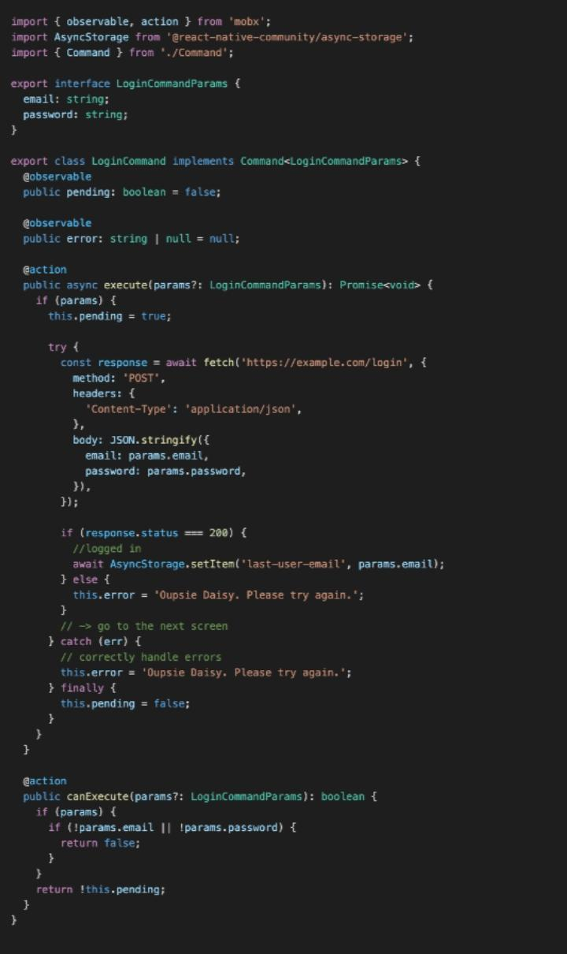

**Custom Development Steps**

**Technical Architecture: Design the overall structure, including how data will be stored and accessed.**

**Platform Choice: Decide whether to build for iOS (using Swift/Objective-C), Android (using Kotlin/Java), or cross-platform (using frameworks like React Native or Flutter).**

**Front-End Development: Create the user interface (UI) that users will interact with.**

**Back-End Development: Develop the server-side logic, databases, and APIs that power the app.**

**AI and Data Integration: If building an AI-powered app, this involves collecting, processing, and training AI models for personalized coaching and insights.**

**4. Consider Key Considerations**

**Content Creation: You’ll need to create or source the actual fitness and nutrition content (e.g., workout videos, exercise instructions, recipes).**

**Community Building: A crucial part of a successful fitness app is fostering a community around your users.**

**Budget: Custom app development can be costly, with prices varying based on complexity, design, and developer location.**

**Exercise :**

**Exercise is any physical activity that improves fitness and health, offering benefits like increased energy, reduced disease risk, better mood, and stronger muscles and bones. Key principles for a routine include making it a habit, gradually increasing activity, mixing up different types of workouts, and exercising regularly, even for short periods.**

**Benefits of Exercise :**

**Physical Health:**

**Boosts muscle strength and endurance.**

**Improves cardiovascular health, sending oxygen and nutrients to tissues.**

**Helps manage weight and maintain a healthy body composition.**

**Strengthens bones.**

**Reduces the risk of chronic diseases like heart disease, stroke, type 2 diabetes, and cancer.**

**Mental Health:**

**Improves mood and well-being.**

**Relieves stress and helps manage symptoms of conditions like ADHD by increasing brain chemicals like dopamine and serotonin.**

**Daily Function:**

**Increases energy levels, making it easier to perform daily tasks.**

**Maintains joint flexibility.**

**Principles of a Good Exercise Routine**

**Regularity: Make exercise a consistent habit to help your body adapt and improve.**

**Progressive Overload: Gradually increase the intensity or duration of your workouts to continue getting stronger, faster, or more flexible.**

**Variety: Mix up your exercise routine to keep it interesting and prevent burnout or injury.**

**Consistency: Show up regularly for your workouts, even if they are short, to maintain progress.**

**Types of Exercise**

**Exercise can include a wide variety of activities, such as walking, cycling, weightlifting, and more. Before starting a new exercise program, it’s a good idea to check with a healthcare provider, especially if you have any pre-existing health conditions or concerns.**

